Date
USCIS
Attn: NFB AOS
2501 S. State Highway 121 Business
Suite 400
Lewisville, TX 75067
Re: EB-2 Immigrant Petition for Permanent Residency with request for a National Interest Waiver
Petitioner/Beneficiary: Jane GrishamB.Sc., M. Sc.
Nature of submission: ORIGINAL SUBMISSION
Type of Petition: I-140, EB-2 National Interest Waiver
Classification Sought: Immigration and Nationality Act 203(b)(2)(B)
Dear USCIS Officer:
This letter is respectfully submitted in support of my Immigrant Petition for Alien Worker (I-140) sent by me Jane Grisham, as a self-petitioner/beneficiary. I would like to demonstrate my fulfillment of the following EB-2 National Interest Waiver requirements and provide supporting evidence for it.
I am eligible for EB-2 classification as a member of the professions holding an advanced degree pursuant to section 203(b)(2) of the Immigration and Nationality Act, 8 U.S.C. §1153(b)(2) because I hold a Master’s degree in Public Administration, and currently work as a Program and Research Coordinator at the International Burn Institute in Birmingham Alabama; an organization dedicated to improving the health and life of children by providing aid, surgeries, Fire Safety and Burn Prevention education to children.
I further submit evidence and documentation to demonstrate that a waiver of the labor certification in my specific case is in the national interest pursuant to In RE: Matter of DHANASAR, 26 I&N Dec. 884 (AAO 2016), Int. Dec. 3882.
- My proposed endeavor has both substantial merit and national importance.
My area of expertise is delivering Fire Safety and Burn Prevention Education to children. Burns are the second most common and serious injury to young children (0-5 years old) and the third leading cause of death. A study aimed at describing the epidemiology of residential fire related deaths and injuries among children and identifying risk factors for these injuries through a linked dataset for the city of Dallas, Alabama, found that Fireplay (children playing with fire or combustible material) accounted for 42% of all injuries, 62% of deaths in children 0–4 years, and 94% of deaths from apartment and mobile home fires. Most of the fireplay related injuries were from children playing with matches or lighters (Exhibit 10.1). Burn incident statistics show that at least 50% of all burns and nearly 75% of all scalding burns in children can be prevented. Truly, the only way to treat a burn is to prevent it from happening in the first place. Therefore, International Burn Institute established Fire Safety and Burn Prevention education program which is a cost-effective program reaching greater numbers of children resulting in fewer injuries.

- I am well positioned to advance the proposed endeavor.
My advanced degree and evidence of exceptional abilities are testament to the fact that I am well positioned to conduct meaningful and impactful research in the field of Fire Safety and Burn Prevention Education. I hold a Master’s degree in Public Administration (MPA) from University of Alabama Alabama. I am an experienced Program and Research Coordinator at International Burn Institute actively involved in leading fire safety and burn prevention classes for children ranging from pre-school age to 5th grade, parents, caregivers and expecting parents. The goal of this training is to prevent fire and burn injuries by teaching our participants to take precautionary measures. I have been awarded several awards and scholarships, including the Phi Alpha academic honors award for being one of the top students in the MPA program in University of Alabama (Exhibit 8-9). I was also invited to become a member of the insert name of organization. and I am also a member a merit-based scientific society (Exhibit 8-9). In addition, recommendation letters from experts in my field serve as evidence that I am well qualified to advance the proposed endeavor (See chapter 3).
- On balance, it would be beneficial to the United States to waive the job offer and labor certification requirements.
The U.S. Fire Administration (USFA) collects data from a variety of sources to provide information and analyses on the status and scope of the fire problem in the United States. According to data collected by USFA in 2019, there were 1,271,500 fires, 3,704 deaths, 16,600 injuries, and loss of properties resulting to the tune of $14.8 billion (See Exhibit 10.2). African American males (21.6) and American Indian males (17.2) have the highest fire death rates per million population.
My work as a program coordinator at International Burn Institute focuses on educating children on Fire Safety & Burn Prevention, so they can acquire the knowledge to stay safe and grow-up to be healthy and productive members of our society. I am actively creating programs that help educate and prevent future disabilities, especially in children. These programs are interactive educational programs that teaches children The Fire Safety and Burn Prevention teaches lifesaving skills. The program teaches:
i. Safety measures to prevent fire and burns from happening.
ii. Safety skills (and techniques) to save lives in case a fire or burn happens.
iii. First aid to prevent the severity of accidents.
It is imperative that all hands are on deck to prevent fires and burns and save lives. My work as a fire and burn educator and program coordinator has already made outstanding contributions to the field. The International Burn Institute is the ONLY organization in Alabama providing Surgical Treatments and Fire Safety & Prevention Education programs simultaneously. Since inception, INTERNATIONAL BURN INSTITUTE has provided surgical procedures to 120,000 children and aid to over 400,000 children worldwide (See Exhibit 7.0). So far, we have presented our fire and safety education program to schools and currently have 50 more schools in Birmingham willing to partner starting August 2021(See Exhibit 11.5). Our platform continues to contribute to quality health care and greater access to services with the aim of a better future for the population of children in the United States. I will serve the national interest more than an available US worker having the same minimum qualifications. I am an important program officer educating children on Fire Safety & Burn Prevention who cannot be easily replaced. This field requires my expertise for a long time because their long-term projects would be seriously impaired without my contribution.
This letter serves as a guide through all submitted evidence - I will provide references directly from content of the letter. Evidence is placed beneath this letter in the following order:
- My Curriculum Vitae, and Advanced Degrees (See Exhibit 1).
- Recommendation letters and resumes written by outstanding experts from well recognized institutions such as Universities (insert names of institutions) (see Exhibit 2-7).
- Evidence supporting my past track of achievements and impact on the field, including awards, recognitions, scholarships, and membership in professional societies (See Exhibits 8-9)
- Government articles explaining benefits of my work on fire and burns to the United States of America. See Exhibit 10
- Evidence of Current Employment at the International Burn Institute (See Exhibit 11) and
- Documents Pertaining to my Nonimmigrant status– passports, approval notices, I-94, and visas. See Exhibits 12.
- Content of this petition letter is divided into chapters to clearly address all required criteria.

1 Advanced Degree Professional 8
2 Substantial Merit and National Importance 9
2.1 The Need for Fire Safety and Burn Prevention Education in the United States 9
2.2 My Role as Program Coordinanor at International Burn Institute 13
2.3 Summary of Benefits to the United States of America 17
3 I am Well Positioned to Advance the Proposed Endeavor 19
3.1 Advanced Degree 20
3.2 Past Record of achievements and Impact on the field 21
3.2.1 My Contribution to Fire Safety and Burn Prevention Education 24
3.2.2 Awards and Scholarships 26
3.3 Member in a professional association 26
3.4 Evidence of Employment at the International Burn Institute 27
4 Beneficial to the USA to Waive the Labor Certification 27
4.1 My Prior Achievements Justify Projected Future Benefits. 27
4.2 My Unique Skills, Knowledge, and Background Serve the National Interest. 28
4.3 I will serve the national interest to a substantially greater degree than others with minimum qualifications. 28
4.4 An Important Fire Safety and Burns Prevention Educator Who Cannot Be Easily Replaced 29
4.5 Consequences of Requiring a Labor Certification. 33
5 Evidence of my Nonimmigrant Status 34
6 Summary 35

Advanced Degree Professional
In December 2019, I earned my Master’s degree in Public Administration (MPA) from University of Alabama (See Exhibit 1.1).
My focus is on Healthcare Administration.
University of Alabama is ranked #1 in XYZ (See Exhibit 1.5).
I received my Bachelor’s degree in Public Administration for the University of Nairobi.
I have included the following documents as evidence of my advanced degree:

Exhibit 1.0: Advanced Degrees

Exhibit 1.0: My Curriculum Vitae
Exhibit 1.1: M.Sc. Degree Certificate University of Alabama
Exhibit 1.2: M.Sc. Transcript University of Alabama
Exhibit 1.3: B.Sc. Degree Certificate Public Administration University of Nairobi
Exhibit 1.4: B.Sc. Transcript Public Administration University of Nairobi
Exhibit 1.5: Ranking of University of Alabama (insert website) Based on the facts demonstrated above, I qualify for the EB-2 classification as a member of the professions holding an advanced degree.

Substantial Merit and National Importance
I am an experienced Program and Research Coordinator at International Burn Institute; a nonprofit, charitable organization founded in 1997, providing high quality reconstructive surgical care along with fire safety and burn prevention education to children locally and globally. Since inception, International Burn Institute has provided surgical procedures to 80,000 children and aid to over 400,000 children worldwide (See Exhibit 7.0). My job is focused on delivering fire safety and burn prevention classes to pre-school age to 5th grade children, parents, caregivers and expecting parents to prevent fire and burn injuries by taking precautionary measures.

The Need for Fire and Burns Educators in the United States
The American Burn Association (ABA) National Burn Repository 2019 reports that, overall, flame burns are still the majority of injuries in the USA (41%), with scalds second at 31%. Chemical (3.5%) and electrical burn injuries (3.6%) occur much less commonly. In Alabama, between the years 2006-2010, fire and burn injuries were the 4th leading causes of unintentional injury and death for both children ages 1 to 4 and 5 to 9 years. Each year, 90% of all fire-related deaths are due to home fires and out of that 67% of all home fires are caused by children (See Exhibit 10.3).
Burn injuries continue to be one of the leading causes of unintentional death and injury in the United States. Between 2011 and 2015, approximately 486,000 fire or burn injuries were seen at Emergency Departments. In 2016 alone, there were 3,390 civilian deaths from fires, which includes 2,800 deaths from residential structure fires, 150 deaths from non-residential structure fires 355 from vehicle fires, and 85 from outside and unclassified fires other than structure or vehicle fires. One civilian fire death occurs every 2 hours 35 minutes. Tragically, children, and the disabled are especially vulnerable to burn injuries. Almost one-quarter (24%) of all burn injuries occur in children under the age of 15. Unintentional fire or burn injuries where the 5th leading cause of injury deaths in the United States in 2015 for children age 1-4, and the 3rd for those age 5-9. In those >65 burn injury was the 8th leading cause of death. In 2011-2015, children under five are 2.4 times as likely as the general population to suffer burn injuries that require emergency medical treatment. Today, 96.7% of those treated in burn centers will survive, unfortunately, many of those survivors will sustain serious scarring, life-long physical disabilities, and adjustment difficulties (See Exhibit 10.4).

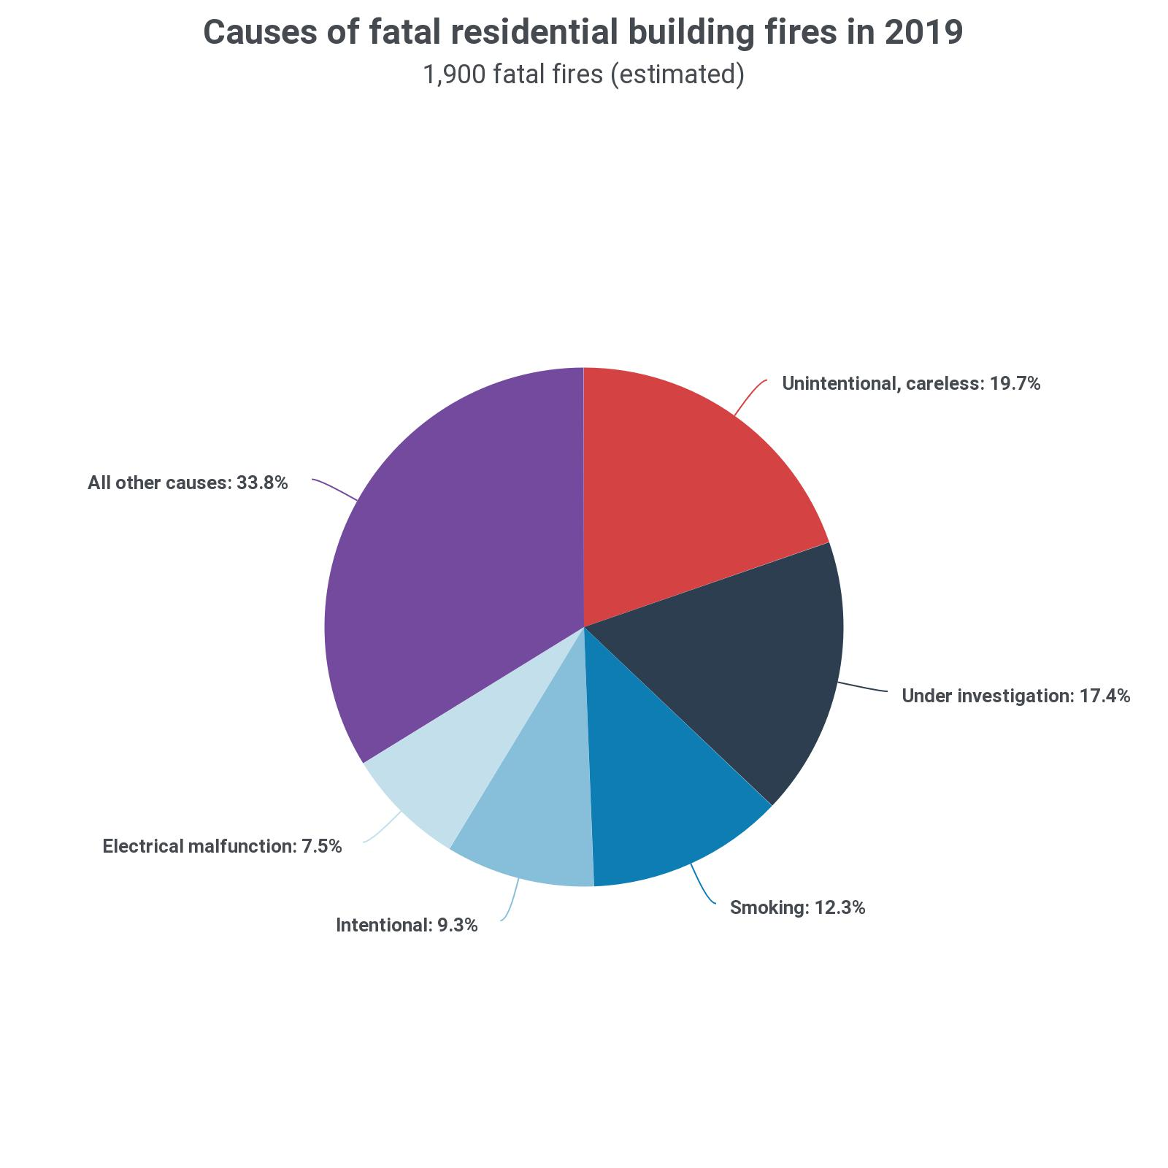
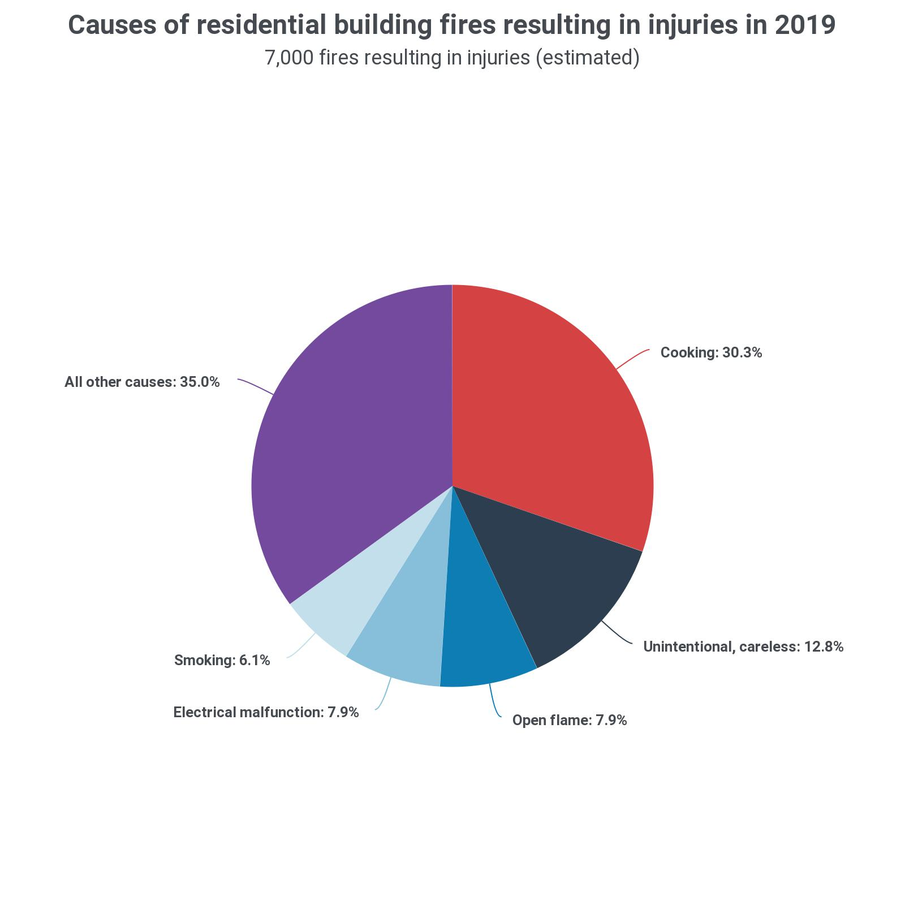
Not only can burn-related injuries leave patients with lifelong physical disabilities, but burns can also result in severe psychological and emotional distress due to scarring. Some of issues faced with people with disabilities are inadequate education, inadequate employment opportunities, issues in healthcare navigation, care management services, inadequate transportation, and inadequate housing which has led people with disabilities excluded in the community. These issues the people with disabilities face have impacted the US health care system, resulting to a huge effect on the economy. The solution for healthcare to move into a quality driven direction is to establish a prevention education program that will help educate and prevent future disabilities.
Figure 1: Fire injuries and fatalities in the USA in 2019. (See Exhibit 10.3: Burn Injury https://www.usfa.fema.gov/data/statistics/
Insert name of recommender 1; an Associate Professor of Plastic Surgery and Head of Department Burns & Plastic Surgery Department at ADA Hospital Lahore Canada, who regularly treats fire and burn victim’s comments on the need for fire safety and burn prevention for children when he wrote a recommendation letter for me for the purpose of the EB2-NIW application. He comments that
“I have been working with Jane Grisham for over two years. She designed a fire safety and burn prevention program in Birmingham. We have used that campaign I Canada of ADA Hospital. The campaign raised awareness and has resulted in reduction of 23.5% patients in Acute burn. Fire safety and burn prevention for children not only prevents deaths but also lifelong disability It is in the nations interest to design, launch and expand this program. Burns are the second most common and serious injury in young children (0-5 years old), but the third leading cause of death. In children, one out of every 13 structure fire death is caused by a child setting a fire (Journal Burn Care & Rehabilitation). Burn incident statistics show that at least 50% of all burns and nearly 75% of all scalding burns in children can be prevented. Truly the only way to treat a burn is to prevent it from happening in the first place”.
(See Exhibit 6.0, emphasis added.)
Insert name of recommender 1’s full recommendation letter and curriculum vitae are all available in Exhibit 6.0 and 6.1 respectively.
2.2 My Role as Program Coordinator for Fire Safety and Burn Prevention at International Burn Institute
The International Burn Institute is the ONLY organization in Alabama providing Surgical Treatments and Fire Safety & Prevention Education programs simultaneously. Since inception, INTERNATIONAL BURN INSTITUTE has provided surgical procedures to 29,750 children and aid to over 175,000 children worldwide (See Exhibit 7.0). As a program coordinator at International Burn Institute, I conduct research, write research and grant proposals for the organization. I also arrange and manage fire safety and burn prevention presentations by coordinating schedules with various schools, preparing flyers and creating presentation materials.
We have established a cost-effective fire safety and burn prevention program, to reach children in the Birmingham area.
Although scald burns can happen to anyone, young children, older adults and people with disabilities are the most likely to incur such injuries. Studies have shown that children who live in crowded housing and in families with low socioeconomic status are at higher risk for scald burns. Other related risk factors may include a lack of safe play environments, single and/or young mothers, and poor maternal. In the United States, in 2003, an estimated 83,300 children ages 14 and under were treated in hospital emergency rooms for burn-related injuries, 15,000 children are hospitalized annually with burn injuries and 1,100 children die each year from fire and burns. In the case of Scald burns, approximately 21,000 children were treated for scald burns in the year 2003, among children ages 4 and under hospitalized for burn-related injuries, an estimated 65% are treated for scald burns, and the total annual cost of scald burn-related deaths and injuries among children ages 14 and under is $44 million. Children 4 and under account for more than 90 percent of these costs (See Exhibit 10.4).
With this initiative, we have opened a channel for recruiting students for Ambassador program. Our brand ambassadors will help us maximize our reach and increase awareness through consistent and focused fire safety and burn prevention message through social media. Currently, we have brand ambassadors from Christian Lobb High School, our recipients’ students and teachers are from: Christian Lobb, Venn Elementary, Ever Green Academy. We have also embraced and implemented virtual learning presentations to reach our participants. This virtual learning is a 30-minute interactive show that teaches i) Safety measures to prevent fire and burns from happening, ii) Safety skills to save lives in case a fire or burn happens, and iii) First aid to prevent the severity in case of an accidents. Students will join via TEAMS in smaller groups (One classroom at a time) and there is a stage play showing on screen with Scripts and songs. We use the children’s favorite cartoon characters i.e. Dora the explorer to ask questions during the interactive session.
So far, we have partnered with 16 schools, and I have conducted a virtual presentation of our Fire Safety and Burn Prevention. Currently with help from the Mayor of the City of Alabama, I have 50 more schools in Birmingham willing to partner starting September 2021 (See Exhibit 11.5).
Our goal is to partner with more schools outside Alabama as the program develops. Also, we have been contacted by the Fire Department of Birmingham contacted us for partnership. Insert name of recommender 5, The Mayor of the City of Alabama stated that this program will ensure safe environment for our children and youths (See Exhibit 11.5).
The Mayor of the City of Alabama Insert name of recommender 5 highly recognized and commended International Burn Institute and proclaimed February 7-13 as the Fire Safety and Burn Prevention Week, by issuing a proclamation which says in part that

“on the days of February 7 through 13, 2021, in observance of National Burn an Awareness week, International Burn Institute’s Fire Safety and Burn Prevention Education program will be recognized for its positive endeavors on behalf of the residents of Birmingham. The city of Birmingham appreciates and thanks al the International Burn Institute and encourages Birminghamians to join in working towards the common goal of fostering safe environments for our youths. Therefore I, Insert name of recommender 5, Mayor of the City of Alabama, hereby proclaim February 7 through 13 ,2021 as FIRE SAFETY and BURN PREVENTION WEEK in Birmingham, Alabama.”
(See Exhibit 11.1, emphasis added.)
A copy of Mayor Insert name of recommender 5’s full proclamation is available in Exhibit 11.1
The founder and executive director of International Burn Institute Insert recommender 2 highlights the importance of my role as an administrator of fire and burn safety.

“The International Burn Institute “Fire Safety and Burn Prevention Education program is a 30-minute interactive show that teaches i) Safety measures to prevent fire and burns from happening, ii) Safety skills to save lives in case a fire or burn happens, and iii) First aid to prevent the severity in case of an accidents.
Through Jane’s initiative to introduce the International Burn Institute Fire Safety and Burn Prevention program to Dublac High School for Health Professions, the International Burn Institute was able to participate in a symposium at DeBakey, where we present our Fire safety and Burn prevention education program to the students. With this initiative, International Burn Institute opened a channel for recruiting students for Ambassador program. These brand ambassadors will help us maximize our reach and increase awareness through consistent and focused fire safety and burn prevention message through social media.”
(See Exhibit 7.0, emphasis added.)
Insert recommender 2’s full recommendation letter and curriculum vitae are all available in Exhibit 7.0 and 7.1 respectively.
Insert recommender 3 a Development Manager at International Burn Institute has worked with me on several projects and can attest to our work.
“The work we do together brings awareness to the issue of burns in children. It highlighted how important it is to educate the children and adults alike in efforts to prevent fires and burn injuries. Our mission is to prevent the pin and trauma of burn injuries in children, and to heal and give children who have suffered burns the opportunity to reach their full potential, physically, psychologically and socially.”
(See Exhibit 4.0, emphasis added.)
Insert recommender 3’s full recommendation letter and curriculum vitae are all available in Exhibit 4.0 and 4.1 respectively.

2.3 Summary of Benefits to the United States of America
In the US, the second most common and serious injury to children and the third leading cause of death is due to fires. Burn incident statistics show that at least 50 % of all burns and nearly 75% of all scalding burns in children can be prevented. Truly the only way to treat a burn is to prevent it from happening in the first place. The prevention education is of the utmost importance to the welfare of the children population of the United States.

The founder and executive director of International Burn Institute Insert recommender 2 highlights the importance of our work as educators of fire and burn safety.
“Since 2019, Jane has been taking an active leadership role as an advisory board member of the International Burn Institute and as the volunteer coordinator for Fire Safety and Burn Prevention Program.
Since 1997, The International Burn Institute is dedicated to improving the health and life of children and has provided aid, Reconstructive Surgeries, Fire Safety and Burn Prevention Education to more than 195,000 children. Our commitment to helping all children to achieve their full potential and receive the opportunity to develop into healthy and compassionate adults drives our mission. Since our inception in 1997, we have provided aid to more than 175,000 children in America and internationally.
Burns are the second most common and serious injury to young children (0-5 years old) and the third leading cause of death. In children, one out of every 13 structure fire death is caused by a child setting a fire (Journal Burn Care & Rehabilitation). Burn incident statistics show thxat at least 50% of all burns and nearly 75% of all scalding burns in children can be prevented. Truly, the only way to treat a burn is to prevent it from happening in the first place. Therefore, International Burn Institute established Fire Safety and Burn Prevention education program which is a cost-effective program reaching greater numbers of children resulting in fewer injuries.”
(See Exhibit 7.0, emphasis added.)
Insert recommender 2’s full recommendation letter and curriculum vitae are all available in Exhibit 7.0 and 7.1 respectively.

Exhibit 10.0: Research Articles Supporting Fire Safety and Burn Prevention Education
Exhibit 10.1: name of article
Website link

Exhibit 10.2: name of article
Website link

Exhibit 10.3: name of article
Website link

Exhibit 10.4: name of article
Website link

I am Well Positioned to Advance the Proposed Endeavor
Nothing says more about my unique abilities to carry out the proposed endeavor than my record of specific contributions and achievements in the past, which speak to my ability to perform the duties in fire safety and burn prevention education. Such success is solidly supported and documented with this petition, particularly by my outstanding educational background, professional recommendation letters written by 5 experts in the field (from professionals in the field who I DO NOT know personally, but only professionally), and my awards.
All 5 expert recommenders speak highly of my contributions and achievements, indicating that I not only made significant contributions in my research field, but also have become an expert who processes exceptional and unique skills that are hard to define and impossible to quantify as ordinary minimum qualifications required in the process of labor certification.
This chapter aim to:
• describe my past track of achievements at University of Alabama
• show how my particular contributions are important for U.S. national interest
• present myself as an administrator and educator in fire safety and burn prevention
• present how I impacted the field as a whole, and
• show my skills and expertise that set me apart from my peers.

Advanced Degree Professional
In December 2019, I earned my Master’s degree in Public Administration (MPA) from University of Alabama - (See Exhibit 1.1). My focus is on Healthcare Administration. University of Alabama is ranked #1 among all national public universities for a superior education at an affordable cost by the Fiske Guide to Colleges, 2018 (See Exhibit 1.5). I received my Bachelor’s degree in Public Administration for the University of Nairobi. I have included the following documents as evidence of my advanced degree:

Exhibit 1.0: Advanced Degrees

Exhibit 1.0: My Curriculum Vitae
Exhibit 1.1: M.Sc. Degree Certificate University of Alabama
Exhibit 1.2: M.Sc. Transcript University of Alabama
Exhibit 1.3: B.Sc. Degree Certificate Public Administration University of Nairobi
Exhibit 1.4: B.Sc. Transcript Public Administration University of Nairobi
Exhibit 1.5: Ranking of University of Alabama (website)

Based on the facts demonstrated above, I qualify for the EB-2 classification as a member of the professions holding an advanced degree.

Past Record of achievements and Impact on the field
As a measure of my contribution to Fire Safety and Burn Prevention, this section focuses on the records of past achievements to show that I am well positioned to advance the proposed endeavor, which in this case is fire safety and burn prevention education.
As even stronger and more authoritative evidence, a letter of recommendation from my graduate school Professor illustrates that I am well positioned for the work based on my record of academic excellence and success in previous projects.
This recommendation is by Dr. recommender 4 an Assistant Professor in the Department of Social Sciences at University of Alabamaskilled in policy analysis, program evaluation, strategic planning, and in research design. Dr. recommender 4 teaches graduate courses in the Master of Public Administration (MPA) Program, and has experience working with federal, state and local governments and agencies as well as non-profit organizations. Dr. Carr describes my academic achievements and competence as a graduate student at University of Alabama.
In my experience, Jane was a bright and inquisitive student who was diligent about her class attendance and course work. I have had the ability to observe and evaluate Jane’s research, writing, and presentation skills through the course of teaching her. She has a remarkable attention to detail, advanced critical thinking skills and is an effective communicator both verbally and written. Jane is putting those skills to use at the only organization in the state of Alabama that works to educate children on Fire Safety and Burn Prevention where she currently develops educational content and assists in preparing and presenting that content to children in schools. Jane’s performance in my class, combined with her s, combined with her professional experience, informs my belief that she Jane should be granted permanent residency.”
(See Exhibit 2.0, emphasis added.)
Dr. recommender 4’s full recommendation letter and curriculum vitae are all available in Exhibit 2.0 and 2.1 respectively.
In addition, the Student Activities Coordinator for the Student Activities Office at University of Alabama- Recommender 5 who oversees student organizations and leadership programming, recommends me highly based on my performance in the Graduate Assistant for Leadership & Training program.
“It brings me immense pleasure to write this letter of recommendation for Jane Grisham, who is applying for Permanent Residency in the United States. In the fall of 2018, I hired Jane for the Graduate Assistant for Leadership and Training position mentioned above. I had the pleasure of supervising Jane in this position for over a year. During this time, Jane showed a true passion for helping our students develop their leadership skills through presentations and programs she developed and facilitated. In addition to this, Jane also assisted in the hiring, training, and supervising of two student employee positions for our office. Jane was an essential part of our Student Activities team and a great representation of our office. In addition to her position related tasks, Jane also represented the office by serving on committees, presenting at New Student Orientations, and partnered with the Associate Director of Student Activities for student employee development programs and trainings”
(See Exhibit 5.0, emphasis added.)
Recommender 5’s full recommendation letter and curriculum vitae are all available in Exhibit 5.0 and 5.1 respectively.

My Contribution to Fire Safety and Burn Prevention Education
The International Burn Institute is the ONLY organization in Alabama providing Surgical Treatments and Fire Safety & Prevention Education programs simultaneously. Since inception, International Burn Institute has provided surgical procedures to 29,750 children and aid to over 175,000 children worldwide. As a program coordinator at International Burn Institute, I conduct research, write research, and write grant proposals for the organization. I also arrange and manage burn prevention presentations by coordinating schedules with various schools, preparing flyers and creating presentation materials.
We have established a cost-effective fire safety and burn prevention program, to reach children in the Birmingham area. With this initiative, we have opened a channel for recruiting students for Ambassador program. Our brand ambassadors help us maximize our reach and increase awareness through consistent and focused fire safety and burn prevention message through social media. Currently, we have brand ambassadors from Christian Lobb High School, our recipients’ students and teachers are from: Christian Lobb, Venn Elementary, Ever Green Academy. We have also embraced and implemented virtual learning presentations to reach our participants. This virtual learning is a 30-minute interactive show that teaches i) Safety measures to prevent fire and burns from happening, ii) Safety skills to save lives in case a fire or burn happens, and iii) First aid to prevent the severity in case of an accidents. Students join via TEAMS in smaller groups (One classroom at a time) and a stage play shows on the screen with Scripts and songs. We use the children’s favorite cartoon characters i.e., Dora the explorer to ask questions during the interactive session to make learning effective.
So far, we have partnered with 16 schools where I have conducted presentations of our Fire Safety and Burn Prevention program. Currently with help from the Mayor of the City of Alabama, I have 50 more schools in Birmingham willing to partner starting August 2021 (See Exhibit 11.5).
Our goal is to partner with more schools outside of the state of Alabama as the program develops. Additionally, Insert name of recommender 5, The Mayor of the City of Alabama stated that this program will ensure safe environment for our children and youths (See Exhibit 11.1).
Recommender 5 the Student Activities Coordinator for the Student Activities Office at University of Alabama- speaks on the essential need for my role as the program Coordinator and research assistant at the International Burn Institute.
“It is apparent that Jane utilizes her effective communication, program development, and training skills from her Graduate Assistant position in her current position as the Program Coordinator and Research Assistant for the International Burn Institute.
The research and education that Jane does regarding fire safety and burn prevention is essential for keeping children safe.”
(See Exhibit 5.0, emphasis added.)
Recommender 5’s full recommendation letter and curriculum vitae are all available in Exhibit 5.0 and 5.1 respectively.
Exhibit 8.0: Awards and Scholarships
Exhibit 8.0: Awards and Scholarships
Exhibit 8.1: Phi Alpha Alpha (December 13, 2019) International Honor Society for Public Affairs Administration
Exhibit 8.2: National Society of Leadership and Success (November 23, 2019)
Exhibit 8.3: Certificate of Achievement University of Alabama
Exhibit 8.4: President academic scholarship August 2018
Exhibit 8.5: College of Liberal art academic scholarship August 2018
Exhibit 8.6: International student’s scholarship January 2019

Member in a professional association
Exhibit 9.0: Membership in Merit Based Professional Societies
I am a member of 2 merit-based scientific organizations.
Exhibit 9.1: National Society of Leadership and Success (2019-Present)
Exhibit 9.2: International Honor Society for Public Affairs Administration (2019-Present)

Evidence of Employment at International Burn Institute
I hereby submit the following documents as evidence of my current employment at the International Burn Institute Alabama.
Exhibit 11: Evidence of Employment

Exhibit 11.1: Proclamation by The Mayor of Birmingham
Exhibit 11.2: Press Release by Founder of International Burn Institute Birmingham Alabama
Exhibit 11.3: Current Employment Letter – International Burn Institute
Exhibit 11.4: My Identity Card from International Burn Institute
Exhibit 11.5: Evidence of all the schools we have worked with and those we plan to work with

Beneficial to the USA to Waive the Labor Certification
It would be beneficial to the USA to waive the Labor Certification because the national interest would be adversely affected if a labor certification were required.

My Prior Achievements Justify Projected Future Benefits.
My impactful contributions in the field of Fire Safety and Burn prevention as discussed in Section 3.2 above, prove my ability to provide unprecedented, unparalleled, and vital benefits to the national interest. I have a truly impressive record of success in education children on fire and burn prevention as evidenced in part by my exceptional abilities (Exhibit 8-9) Further, these contributions have been well above those of others with similar formal qualifications. I Possess Unique Skills, Knowledge, and Background that Serve the National Interest.
As can be seen from my recommendation letter and commendations (Exhibit 2-7), I have highly valuable skills for my ongoing work. In addition to my technical expertise, I am distinguished through special traits like uncommon intellect and work ethic. Certainly, such factors are beyond the scope of a labor certification process. All my special skills, abilities, and knowledge combined with past record of success make me ideally suited to educating children and parents on fire safety. Moreover, these unique traits cannot be articulated in a labor certification process.

I Will Serve the National Interest to a Substantially Greater Degree than Others with Minimum Qualifications.
My outstanding accomplishments and exceptional abilities (above) prove my capacity to perform at a level above that of others with similar minimum qualifications.
Dr. Sarah Scott, who is an Associate Professor of Criminal Justice and Public Administration in the Department of Social Sciences in University of Alabama- ( comments on my degree of expertise in his letter of recommendation.
“Jane is presently employed as a Program Coordinator and Research Assistant at the International Burn Institute in Birmingham, Alabama where she works in fire safety and burn prevention for children to prevent disabilities. The International Burn Institute is the only organization in the state that provides both surgical treatments and fire safety and prevention education simultaneously. Jane works to educate children, parents, expecting parents, and caregivers on important safety measures. It is estimated that her program reaches over
200,000 children a year, and there is evidence to support the effectiveness of the program. Given the reach of the program, and the contribution she is making to public health and safety, I believe it is clear that Jane’s work is in the national interest. In conclusion, I very strongly recommend that Jane Grisham be granted Permanent Residency approval.
(See Exhibit 4.0, emphasis added.)
Dr. Sarah Scott’s full recommendation letter and curriculum vitae are all available in Exhibit 4.0 and 4.1 respectively.
Therefore, I will serve the national interest to a substantially greater degree than will most others with the same minimum qualifications. The labor certification process should not be used in my special case. On balance, it would be beneficial to the United States to waive the job offer and labor certification requirements.

An Important Fire Safety and Burn Prevention Educator Who Cannot Be Easily Replaced
I currently work as a Program and Research Coordinator at International Burn Institute a nonprofit, charitable organization founded in 1997, providing high quality reconstructive surgical care along with fire safety and burn prevention education to children locally and globally. Since inception, International Burn Institute has provided surgical procedures to 29,750 children and aid to over 175,000 children worldwide. (See Exhibit 7.0).
Insert recommender 2, the Founder and Executive Director of International Burn Institute highlights the importance of my role as a Fire Safety and Burn Prevention Educator, and the significant impact that I have made so far in her recommendation letter where she recommends me for permanent residency under the EB2NIW category

“Through Jane’s initiative to introduce the International Burn Institute Fire Safety and Burn Prevention program to Dublac High School for Health Professions, the International Burn Institute was able to participate in a symposium at DeBakey, where we present our Fire safety and Burn prevention education program to the students. With this initiative, International Burn Institute opened a channel for recruiting students for Ambassador program. These brand ambassadors will help us maximize our reach and increase awareness through consistent and focused fire safety and burn prevention message through social media.
… Jane has my highest recommendation United States Permanent Residency in category EB-2 National Interest Waiver because with her compassion and commitment to the community, I am certain that she will continue to do great things in her future and will be a great asset to United States.”
(See Exhibit 7.0, emphasis added.)
Insert recommender 2’s full recommendation letter and curriculum vitae are all available in Exhibit 7.0 and 7.1 respectively.
Recommender 5 the Student Activities Coordinator for the Student Activities Office at University of Alabama- speaks on the value of my skill to the community and to the Unites States.
“The drive, passion, and professionalism Jane brings to all her positions and to life is everything an employer could ask for. Jane has made such a positive impression upon the University of Alabama- community. Because of this and the many reasons mentioned above, I strongly recommend that Jane Grisham be granted Permanent Residency in the United States.”
(See Exhibit 5.0, emphasis added.)
Recommender 5’s full recommendation letter and curriculum vitae are all available in Exhibit 5.0 and 5.1 respectively.
Recommender 3 Development Manager at International Burn Institute speaks on the value of my skills
“It is of great value to the United States to attract professionals like Jane, whose experience and track record in identifying and tackling the issues faced by the population of children with burns in the United States. I strongly recommend Jane Grisham for permanent residency.”
(See Exhibit 4.0, emphasis added.)
Insert recommender 3’s full recommendation letter and curriculum vitae are all available in Exhibit 4.0 and 4.1 respectively.

Finally, Dr. recommender 4 an insert title and affiliation of recommender who has experience working with federal, state, and local governments and agencies as well as non-profit organizations describes the unique skills that I possess that make me an asset to the United States.
“In my experience, Jane was a bright and inquisitive student who was diligent about her class attendance and course work. I have had the ability to observe and evaluate Jane’s research, writing, and presentation skills through the course of teaching her. She has a remarkable attention to detail, advanced critical thinking skills and is an effective communicator both verbally and written. Jane is putting those skills to use at the only organization in the state of Alabama that works to educate children on Fire Safety and Burn Prevention where she currently develops educational content and assists in preparing and presenting that content to children in schools. Jane’s performance in my class, combined with her professional experience, informs my belief that she Jane should be granted permanent residency.”
(See Exhibit 2.0, emphasis added.)
Dr. recommender 4’s full recommendation letter and curriculum vitae are all available in Exhibit 2.0 and 2.1 respectively.

Consequences of Requiring a Labor Certification.
As much of the proposed benefits from my work are dependent on my proven record of achievement and unique and innovative skills, knowledge, and background, more than mere minimum qualifications are required for the success of my proposed endeavors. Because a labor certification process is a standardized one that relates only to minimum requirements, such a process will not consider these crucial factors. In other words, many of the essential qualities that I have, which are so important to serving the national interest, will not be articulated in a labor certification process. Moreover, failure to consider these factors could result in a denial of a labor certification because a U.S. worker with minimum qualifications might be found. Since I will serve the nation to a substantially greater degree than anyone with minimum qualifications will, non-participation in my current and future work would deprive the nation of exceptional and crucial contribution to the national interest. The loss of this significant contribution would be contrary to the interests of the United States. Therefore, requiring a labor certification would adversely affect the national interest

Evidence of my Nonimmigrant Status
I submit the following evidence of non-immigrant status
Exhibit 12: Evidence of My Non-immigrant status
Exhibit 12.1: F1 Visa Stamps
Exhibit 12.2: Passport Photo Page
Exhibit 12.3: Current I-94
Exhibit 12.4: Previous I-94
Exhibit 12.5: OPT Cards
Exhibit 12.6: All Form I-20

Summary
I provided evidence to demonstrate my extraordinary skills and unique experience as a program administrator for fire safety and burn prevention. Burns are the second most common and serious injury to young children (0-5 years old) and the third leading cause of death.
Not only can burn-related injuries leave patients with lifelong physical disabilities, but burns can also result in severe psychological and emotional distress due to scarring. Some of issues faced with people with disabilities are inadequate education, inadequate employment opportunities, issues in healthcare navigation, care management services, inadequate transportation, and inadequate housing which has led people with disabilities excluded in the community. These issues the people with disabilities face have impacted the US health care system; resulting to a huge effect on the economy. The solution for healthcare to move into a quality driven direction is to establish a prevention education program that will help educate and prevent future disabilities.
Research shows that in all the developed world, the U.S has the highest number of fires caused by children and that alone is a startling fact that is compelling enough to make fire prevention education necessary in the U.S. The consequences that result from burns are serious, including isolation from or even abandonment by the family, social segregation, lack of education and/or skills, and extreme poverty. The long-term consequences and disability place a considerable strain on individuals and their families. Hence, the society at large. The survivor’s family find pre-injury poverty levels worsen after recovery. An educative program will provide a safe environment for our children, youths, and parents. The solution to this problem is prevention. Truly the best way to treat a burn is to prevent it from happening in the first place. As a society, we need to care about the aftermath of burns especially in children. The best way to treat a burn is to prevent it from happening in the first place. That will help reduce the mortality rate in the U.S. This is because burn injuries lead to long-term profound alterations that can decrease the quality of life of children as they grow. Burn injuries are under-appreciated injuries that are associated with substantial morbidity and mortality. Patients with burn injury cannot be considered recovered when the wounds have healed; instead, burn injury leads to long-term profound alterations that must be addressed to optimize quality of life. Burn injuries, particularly severe burns, are accompanied by an immune and inflammatory response, metabolic changes and distributive shock that can be challenging to manage and can lead to multiple organ failure. Burn injuries result in lifelong physical and psychological scarring causing pain and influencing mental health, quality of life, ability to return to work and subsequent mortality.
GOAL: My work is to educate pre-school to 5th grade children and parents on fire safety and burn prevention, and to engage the public in learning how to avoid accidental fires and burn injuries.
OBJECTIVE: The objective is to create safe communities by altering behavior and common practices of children, parents, caregivers and expecting parents.
My rare, yet vital, skills and background along with impressive record of achievement and unique knowledge relevant to my current and future work indicates that I will serve to the national interest to a substantially greater degree than another individual with minimum qualifications. As a labor certification may not articulate my unique and exceptional future contributions, such a requirement would adversely affect the national interest.
I respectfully request that you consider this petition and the evidence submitted herewith and upon consideration, that you approve my petition and request for a National Interest Waiver. Your attention to my case will be deeply appreciated. Thank you for your time and consideration of my request.

Sincerely,
Signature

Jane Grisham
Title
Organization
Address
Phone #
Email

